To whom it may concern,

You may or may not know me, but I am writing to you today to inform you about a new variation on Intelligent Design known as Pastafarianism and how it affects your business. We Pastafarians believe that the universe and everything contained in it were created by our god, the Flying Spaghetti Monster, or FSM for short. I would also like to present to you a number of possible products you could create and sell. Our religion is also very large and growing rapidly so there is a great market for selling FSM products.

Our story of creation is slightly different then what is proposed by the Intelligent Design supporters. We believe that in the beginning there was nothing but His noodles. Using His noodles, he created a mountain, then some trees to go on that mountain, and then a midget to populate the earth. I have an illustration of this below (Figure 1). This midget was then left to populate the earth, exactly how he did this remains a mystery to us and is not currently known. Very little is known about what happened to the midget after he was created by His noodley appendage. However, it is commonly believed that this midget was a pirate.
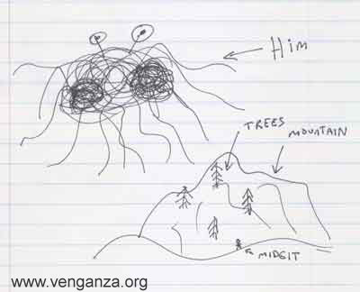
Figure 1

In modern times, pirates are very central to our beliefs. In fact, in the early days of Pastafarianism it was believed that all who wished to spread the good word of the FSM must be fully dressed in pirate regalia. Today that requirement has been lessened, and it is now acceptable to spread the good news in plain street clothes. This was done partly because only a very small number of people possess a full pirate outfit, but many people wished to spread the word and speak of Him to potential believers. Below, I have a picture of some of our supporters handing out FSM related literature. I included this to give you an example of what is considered full pirate regalia.

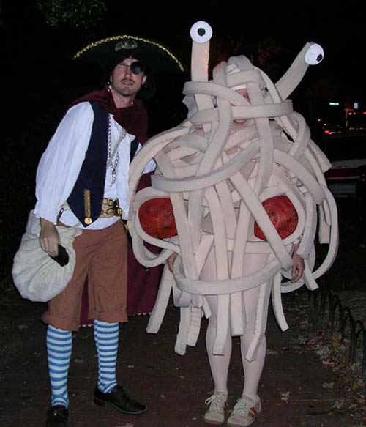
Figure 2

This is where you and your business, Toys ‘R’ Us, come in to play. We believe that there is a great potential for selling play sets featuring Him, the original mountain, trees and midget. Figure 1 is a rather crude drawing, I will admit. However, I think that when applied to a scale model, it should make a very interesting toy for a child to play and learn about how His noodley appendage affects us daily.

However, this is not the only business opportunity I would like to present to you. I would also like to propose a full line of his and her pirate outfits. I am confident that there is a great market for these, as there are very many people who would like to be properly dressed while spreading the word of FSM. I personally know several people who would be very interested in purchasing a pirate outfit for the holiday season.

Like many other religions, we also have a religious holiday during the winter. Ours is simply known as “Happy Holidays”, I am certain that you have heard of it because it is very popular. Similarly, one of our Happy Holidays symbols is the Holiday Tree. We do not believe in destroying actual trees to place them inside our home, after all it may have been one of the original trees. Henceforth, we use artificial trees, draped with spaghetti or something that closely resembles it. Illuminated glass balls are occasionally used to simulate meatballs.

I believe that there is also a potential market for selling these decorations during the Happy Holiday season. As I am sure you are aware, November and December are great months for retail outlets such as yours. It is also a time of year when people seek to look for new meaning in there lives, and we would very much appreciate it if you showed them the way to us.

To recap, I would like to ask for the help of you and your employees in spreading the word of the Flying Spaghetti Monster to all of our potential followers. I also believe that you may profit greatly for helping our cause.

In confidence,

Addison Babcock

Citations and References

Figure 1 Henderson, Bobby. "Open Letter to Kansas School Board." Open Letter to Kansas School Board. Church of the Flying Spaghetti Monster. 3 Nov 2006 <http://www.venganza.org/about/open-letter/>.

Figure 2 Henderson, Bobby. "Halloween Missionaries." Halloween Missionaries. 01 Nov 2005. Church of the Flying Spaghetti Monster. 3 Nov 2006 <http://www.venganza.org/spread-the-word/costumes/>.

